**Experiment no. 8**

**Name: Sonali Dattatray Kaingade**

**PRN: 21620002**

**Title:** Extend program 7, to find association rule.

**code:**

#include <bits/stdc++.h>

#include <map>

using namespace std;

ifstream fin;

double minfre;

vector<set<string>> datatable;

set<string> products;

map<string, int> freq;

double confidence;

// Function to split a string into words

vector<string> wordsof(string str)

{

vector<string> tmpset;

string tmp = "";

int i = 0;

while (str[i])

{

if (isalnum(str[i]))

tmp += str[i];

else

{

if (tmp.size() > 0)

tmpset.push_back(tmp);

tmp = "";

}

i++;

}

if (tmp.size() > 0)

tmpset.push_back(tmp);

return tmpset;

}

// Function to combine a vector of strings, excluding the one at a given index

string combine(vector<string> &arr, int miss)

{

string str;

for (int i = 0; i < arr.size(); i++)

if (i != miss)

str += arr[i] + " ";

str = str.substr(0, str.size() - 1);

return str;

}

// Function to clone a set of strings

set<string> cloneit(set<string> &arr)

{

set<string> dup;

for (set<string>::iterator it = arr.begin(); it != arr.end(); it++)

dup.insert(*it);

return dup;

}

// Generate candidate itemsets for Apriori

set<string> apriori_gen(set<string> &sets, int k)

{

set<string> set2;

for (set<string>::iterator it1 = sets.begin(); it1 != sets.end(); it1++)

{

set<string>::iterator it2 = it1;

it2++;

for (; it2 != sets.end(); it2++)

{

vector<string> v1 = wordsof(*it1);

vector<string> v2 = wordsof(*it2);

bool alleq = true;

for (int i = 0; i < k - 1 && alleq; i++)

if (v1[i] != v2[i])

alleq = false;

v1.push_back(v2[k - 1]);

if (v1[v1.size() - 1] < v1[v1.size() - 2])

swap(v1[v1.size() - 1], v1[v1.size() - 2]);

for (int i = 0; i < v1.size() && alleq; i++)

{

string tmp = combine(v1, i);

if (sets.find(tmp) == sets.end())

alleq = false;

}

if (alleq)

set2.insert(combine(v1, -1));

}

}

return set2;

}

// Count occurrences of a set of items in the dataset

int countOccurences(vector<string> v)

{

int count = 0;

for (auto s : datatable)

{

bool present = true;

for (auto x : v)

{

if (s.find(x) == s.end())

{

present = false;

break;

}

}

if (present)

count++;

}

return count;

}

ofstream fw1("association_output.csv", ios::out);

// Generate subsets of items for association rule generation

void subsets(vector<string> items, vector<string> v1, vector<string> v2, int idx)

{

if (idx == items.size())

{

if (v1.size() == 0 || v2.size() == 0)

return;

int count1 = countOccurences(items); // Total support

int count2 = countOccurences(v1);

double conf = (((double)count1) / count2) * 100;

if (conf >= confidence)

{

fw1 << "Association Rule: { ";

for (auto s : v1)

{

fw1 << s << " ";

}

fw1 << "} -> {";

for (auto s : v2)

{

fw1 << s << " ";

}

fw1 << "} , Confidence: " << conf << "%" << endl;

}

return;

}

v1.push_back(items[idx]);

subsets(items, v1, v2, idx + 1);

v1.pop_back();

v2.push_back(items[idx]);

subsets(items, v1, v2, idx + 1);

v2.pop_back();

}

// Generate association rules from frequent itemsets

void generateAssociationRules(set<string> freqItems)

{

for (auto it = freqItems.begin(); it != freqItems.end(); it++)

{

vector<string> items = wordsof(*it);

subsets(items, {}, {}, 0);

}

}

int main()

{

fin.open("association_input.csv", ios::in);

if (!fin.is_open())

{

cerr << "Error in opening file." << endl;

return 1;

}

cout << "Enter Minimum Support (%): ";

cin >> minfre;

cout << "Enter Minimum Confidence (%): ";

cin >> confidence;

string str;

while (!fin.eof())

{

getline(fin, str);

vector<string> arr = wordsof(str);

set<string> tmpset;

for (int i = 0; i < arr.size(); i++)

tmpset.insert(arr[i]);

datatable.push_back(tmpset);

for (set<string>::iterator it = tmpset.begin(); it != tmpset.end(); it++)

{

products.insert(*it);

freq[*it]++;

}

}

fin.close();

cout << "Number of transactions: " << datatable.size() << endl;

minfre = minfre * datatable.size() / 100;

cout << "Minimum Frequency Threshold: " << minfre << endl;

queue<set<string>::iterator> q;

for (set<string>::iterator it = products.begin(); it != products.end(); it++)

if (freq[*it] < minfre)

q.push(it);

while (q.size() > 0)

{

products.erase(*q.front());

q.pop();

}

int pass = 1;

cout << "Frequent " << pass++ << "-item set: " << endl;

for (set<string>::iterator it = products.begin(); it != products.end(); it++)

cout << "{" << *it << "} - Support: " << freq[*it] << endl;

int i = 2;

set<string> prev = cloneit(products);

while (i)

{

set<string> cur = apriori_gen(prev, i - 1);

if (cur.size() < 1)

{

break;

}

for (set<string>::iterator it = cur.begin(); it != cur.end(); it++)

{

vector<string> arr = wordsof(*it);

int tot = 0;

for (int j = 0; j < datatable.size(); j++)

{

bool pres = true;

for (int k = 0; k < arr.size() && pres; k++)

if (datatable[j].find(arr[k]) == datatable[j].end())

pres = false;

if (pres)

tot++;

}

if (tot >= minfre)

freq[*it] += tot;

else

q.push(it);

}

while (q.size() > 0)

{

cur.erase(*q.front());

q.pop();

}

bool flag = true;

for (set<string>::iterator it = cur.begin(); it != cur.end(); it++)

{

vector<string> arr = wordsof(*it);

if (freq[*it] < minfre)

flag = false;

}

if (cur.size() == 0)

break;

cout << "\nFrequent " << pass++ << "-item set: " << endl;

for (set<string>::iterator it = cur.begin(); it != cur.end(); it++)

cout << "{" << *it << "} - Support: " << freq[*it] << endl;

prev = cloneit(cur);

i++;

}

generateAssociationRules(prev);

cout << "Association rules generated successfully." << endl;

return 0;

}

**Output:**

**input.csv:**

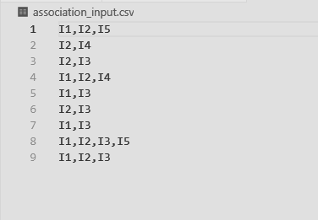

**output.csv:**

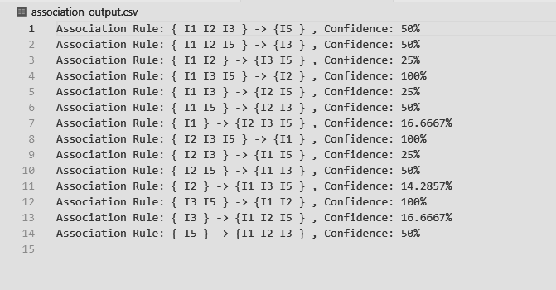

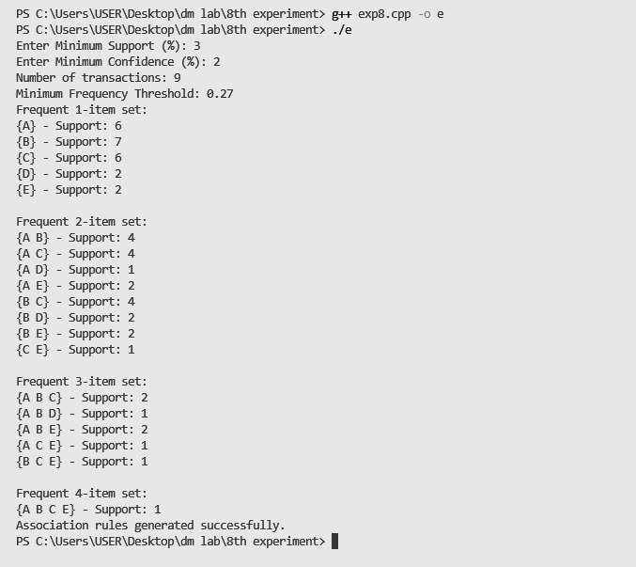

**knime:**

